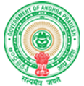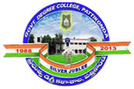**Government Degree College**

**ACCREDITED BY NAAC WITH ‘B’ GRADE** **Pattikonda,Kurnool (Dt),A.P.518380.**

**Dr R Madhuri,**

**Principal ,**

**The functioning of the institutional bodies is effective and efficient as visible from policies, administrative setup, appointment and service rules, procedures, etc.**

**At the institutional level, the principal is the academic and administrative leader. Decisions regarding university affairs and academic affairs are made by the CPDC or the Staff Council after careful consultation. Academic decisions at this level are made with full consideration of IQAC recommendations.**

**The Principal, through academic and administrative departments such as the Admissions Committee, Academic Committee, Examinations Committee, NSS Committee, Library Committee, Timetable Committee, Anti-Lagging Committee, Complaints Resolution Cell, Research Committee, etc. directs the process of Each Committee shall be convened by a Senior Teacher and headed by two or more of her members appointed by both faculty and non-faculty to make decisions and implement them.**

**The decision-making process therefore reflects internal democracy and participatory control at all levels.**

**The administrative hierarchy is shown below.**

**• Higher Education Officer**

**• Regional Director for Higher Education**

**• Principal**

**.** 